Newsletter

**Cooperative Extension Service**

Ballard County

110 Broadway

LaCenter Ky 42056

(270) 665-9118

Fax: (270) 665-5241

extension.ca.uky.edu





December 2023

**All meetings will be held at the Ballard County Extension Office, 110 Broadway LaCenter, unless otherwise stated. If school is cancelled due to weather or sickness, our meetings are cancelled too.**

**SAVE THE DATE**

**4-H CAMP**

**July 8-11, 2024**

BALLARD, FULTON, MARSHALL, HART, BARREN AND MONROE

COST $320



|  |  |
| --- | --- |
|  |  |
| December 6 | Cooking Club, 3:20-4:30pm (must already be enrolled in cooking club) |
| December 11 | Ballard County 4-H Council, 4:30pm |
| December 12 | Art Club, 3:20-4:30pm |
| Dec. 13 | Explorers Club 3:20-4:30pm |
| December 14 | PREPARATION FOR 4-Hers, PARENTS AND TEENS INTERESTED IN THE FLOAT FOR THE DECEMBER 16 CHRISTMAS PARADE 6pm, Jason Enlow’s Shop across from 3935 Lester Harris Road, Kevil (See newsletter for more info.) |
| December 16 | Christmas Parade, La Center; Be at fairgrounds by 5:30pm; parade starts at 6pm; **hot chocolate at 4-H office during parade and soup/chili potluck at the 4-H office after parade**. We will unload trailer at the back of the 4-H Office for pick-up rather than going back to fairgrounds. |
| Not meeting | Livestock, Horse, Leadership Clubs |
| December 25-January 1 | Closed for Christmas |
| March 21-23 | 4-H Summit, West Ky 4-H Camp |
| July 8-11, 2024 | 4-H Camp, Dawson Springs KY |



**Christmas Parade in LaCenter**

CALLING FOR HELP! Jason and Katie Enlow

have generously offered their trailer, straw and building skills again this year for a 4-H Christmas Parade entry for Saturday, December 16. There is a preparation get together on Thursday, December 14 at 6pm at the Enlow’s Shop across from 3935 Lester Harris Road, Kevil. Jason has a large star and is building a frame. We have a “4” and an “H” from Larry, Charissa and Molly Harris. We will be decorating the tree, frame and clover. We have lights. We need adults to bring staple guns, please. Youth can help do the lights. **Also let us know if you plan to be in parade with us so we will have a count.**

We will have taco soup and some other soups. If you can’t bring some, don’t let that stop you from bringing your kids and enjoying warming up!

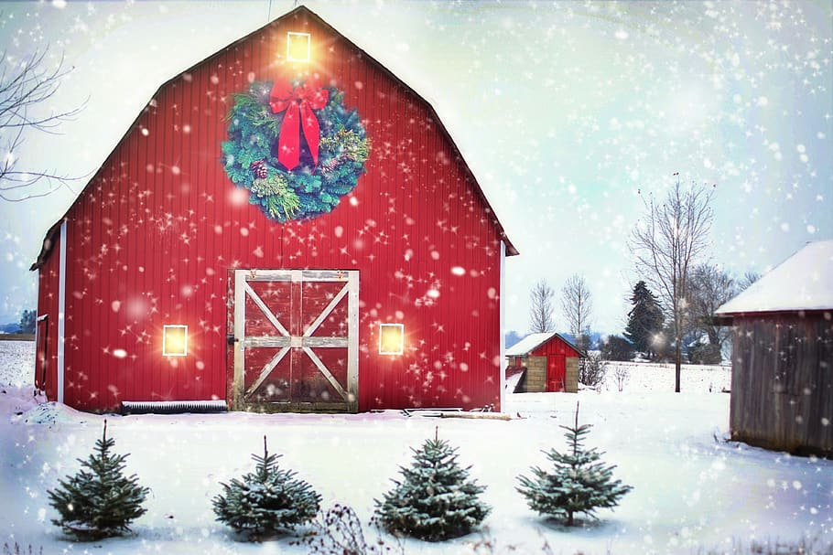

**Service Learning**

“Hands to larger service”, is part of the 4-H Pledge. We encourage all of our 4-Hers for participate in service projects for the community. Whether it be a toy drive, food drive or whatever is needed.



Released by:



Ballard County Extension Agent

For 4H/Youth Development

**Congratulations!**

Congratulations to all our 4-H Banquet Awards Recipients. The Meritorious Service Award was awarded to the Ballard County Kentucky Farm Bureau. The Conrad Feltner Adult and Teen Awards went to Roxie Blankenship and Teddy Blankenship respectively. The JD Hampton Award went to Devante Hollowell. The Special Friend of 4-H Award was awarded to Christy Webster. The 4-H Alumni Award was presented to Nancy Courtney. The Outstanding 4-H Supporter was presented to Justin Puckett. A 4-H Showcase was also done. Youth were recognized for leadership and involvement this past year.

**Many Thanks!**

Thank you to Ballard County Kentucky Farm Bureau for being our banquet sponsor. Thank you to all of our year round support for many businesses and individuals. Many thanks to our ladies who made desserts for the dessert auction. They were Charissa Harris, Deena Myatt, Betty Jerrell, Mary Miller, Sarah Drysdale, Catherine Hobbs, Pauline Owsley, Mary Pace, Paula Ross, Brandee Myatt, Heather Tilford and Trish Pickett. Lynwood Mathis, Paula Jerrell and Kelly Miller also donated cakes. And those who won the bids on them were Kelly Wray, Steven Rudy, Tina Armer, Randy Jerrell, Pat Sullivan, John Miller, Billy McDanel, Jordan Turnage, Grace Travis and Christy Webster, Lindsey Bowles, Jane Cooper, Charissa Harris, Jill Cooper and Tim Goodin. Clint Dennis was the high bidder. He bought Mary Pace’s Strawberry Cake for $500! Donations were made by Bobbie Wray, James Morrow, Peggy Mereideth and Carol Mathis. A total of $4,184.00 was raised with those who made donations for the event as well. We will give half of this amount to Kenna Bodell and family.

