Ballard County Ag Newsletter
February 2024

The wheat crop and hauling grain are the main concerns as we approach the end of February. It’s time to begin early nitrogen applications if you are going to split apply. I would wait another couple of weeks if I were just applying once. It’s time to scout for aphids and armyworms and also determine
if you are going to need wild garlic control.

We came through the winter in relatively good shape. The mid-January cold snap had me worried, but I think the wheat is fine other than some cosmetic leaf burn. I attended the wheat program in Hopkinsville on February 1st and here are a few of the highlights. Rick Seimer, from Seimer Milling gave a presentation and talked about their operation in Hopkinsville. The operation is quite impressive and a big user of wheat. Being as close to the river as we are, none of our wheat makes it that direction. There was a talk about Carbon Markets and they are changing by the hour so don’t get in too big a hurry to sign-up yet. The marketing session revealed that nobody knows if it is going to go up or down. There will be some weather scares and $6.30 would be a good place to start some sales for this next year.
Disease control was the biggest topic. Fungicide applications for wheat are almost a must--not as much from the yield reduction as from the possible quality reduction. Mid-flower is still the best time to apply a head scab treatment. Maravis Ace does have a little control if sprayed earlier but it has much better control when sprayed at the normal time. All of the recommended products have similar results when sprayed at mid-flower so the price may be a bigger concern this year. Our yield was fantastic last year. The state yield was 88 bushels per acre. Trigg County averaged 100 bushels but Ballard was 4th overall at 94 bushels per acre.
Xtendimax, Engenia, and Tavium Availability in Kentucky for 2024
Dr. Travis Legleiter- Extension Professor Weeds
The United States District Court of Arizona vacated the 2020 Xtendimax, Engenia, and Tavium labels for use in dicamba-resistant soybean on Feb. 6, 2024. This order left the availability of the three products for the 2024 season in limbo for approximately a week. On Feb. 14, 2024 the EPA responded to the court ruling with an Existing Stocks Order allowing the sale and distribution of existing stocks of Xtendimax, Engenia, and Tavium.

What does this all mean for the 2024 growing season and the use of these products? The following information is my interpretation of the EPA Existing Stocks Order and how it may affect Kentucky soybean growers in 2024. If you are in doubt about how to use a product in 2024 or how this order affects you, please refer to the EPA order or the products label, website, or representative. You can find the official EPA Existing Stocks Order at this link: https://www.epa.gov/system/files/documents/2024-02/dicamba-notice-existing-stocks- order_02142024.pdf
The order indicates that the sale and distribution of Xtendimax, Engenia, and Tavium will be allowed by persons other than the registrants until May 31, 2024 in Kentucky. “Persons other than registrants” would include co-ops, local dealers, and commercial distributors. Only product that was in possession of the “other persons” on or before the February 6 court ruling can be sold or distributed.
While a majority of products were already in possession of these “other persons” or “in the channel”, not all product was at this stage on February 6 and thus a full supply availability is highly unlikely to occur.
Furthermore, the order allows for the use or application of these three products by both private and commercial applicators in dicamba-resistant soybean fields until June 30, 2024 in Kentucky. This date aligns with the already established cutoff date for Kentucky.
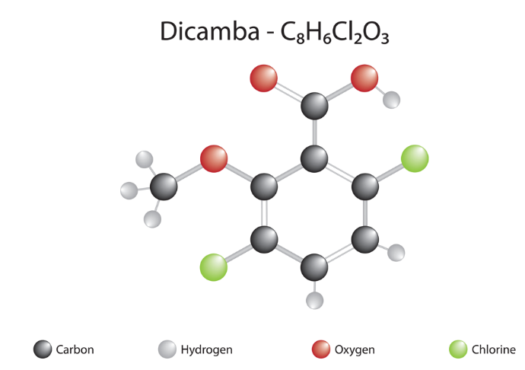
Lastly, and most importantly, ALL APPLICATIONS OF XTENDIMAX, ENGENIA, AND TAVIUM MUST STILL FOLLOW THE RESTRICTIONS IMPLEMENTED ON THE MOST RECENT LABELS INLCUDING THE MANDATORY ANNUAL TRAINING.
Frequently asked questions and scenarios are described below:
• Will there be a shortage of Xtendimax, Engenia, or Tavium? Yes, there will be less supply available in 2024 than will be needed for Kentucky soybean acres. As mentioned above a large majority of Xtendimax, Engenia, and Tavium was likely already in the channel on February 6.
Though there certainly was supply of these products that had not reached the “other persons” by that date and thus a shortage is very likely. Farmers and applicators should make plans now for the potential of a shortage. See the below comments on potential alternatives.
• Can a custom applicator still apply Xtendimax, Engenia, or Tavium to a farmer’s dicamba-resistant soybean field? Commercial applicators will be allowed to apply Xtendimax, Engenia, or Tavium to a farmers dicamba-resistant soybean field until June 30, 2024 in Kentucky. Commercial applicators can apply product that was within their possession or that was in the channel prior to the February 6th ruling.
• Can a farmer spray Xtendimax, Engenia, or Tavium that they have already purchased to their dicamba-resistant soybean fields: Yes, a farmer can apply any product in their posses-ion prior to Feb 6, 2024 to their dicamba-resistant soybean fields until June 30, 2024.
• Can a farmer still buy Xtendimax, Engenia, or Tavium to spray on their dicamba-resistant soybean fields: Yes, a farmer can still buy these products from co-ops, dealers, or distributors who were in possession of the product prior to February 6, 2024. The farmer must purchase the product by May 31, 2024 and apply it prior to June 30, 2024. I would encourage farmers to make these purchases sooner rather than later due to the potential shortage; it is very likely product will no longer be available by the May 31 purchase cutoff.
• It is June 15, 2024 and a farmer who is applying product to their own acres realizes they do not have enough Xtendimax, Engenia, or Tavium for all of their dicamba-resistant soybean acres. Will they be able to buy more to use on the remaining acreage? No. Sales and distribution of Xtendimax, Engenia, and Tavium will conclude on May 31, 2024. In this scenario the farmer has two options: 1. Hire a custom applicator that has extra Xtendimax, Engenia, or Tavium on hand to apply to the remaining acres, or 2. Seek alternative herbicides for weed control in those fields. See the next question and Tables 1 and 2 for alternative herbicides.
• A farmer is worried they will not be able to get enough Xtendimax, Engenia, or Tavium to use on their dicamba-resistant soybean fields. Will they be allowed to use other dicamba formulations on dicamba resistant soybean? No! Only Xtendimax, Engenia, and Tavium are allowed for use on dicamba-resistant soybean. If you are concerned about not having enough dicamba for your dicamba resistant soybean fields I would encourage you to seek alternative postemergence herbicide options in those systems, such as glufosinate. Additionally, you should consider which fields would benefit the most from dicamba and/or glufosinate applications based on weed spectrum. Our research has shown that the use of dicamba and glufosinate in these soybean systems is most valuable on fields with waterhemp or Palmer amaranth infestations, while alternative products can be used on fields without these problematic weeds. See Table 1 and 2 for more information. Additional product information weed control efficacy tables can also be found in AGR-6 (https://www2.ca.uky.edu/agcomm/pubs/agr/agr6/agr6.pdf)
• Is the annual training to apply Xtendimax, Engenia, or Tavium still required in 2024? Yes.
• Does this affect other dicamba formulations or generic dicamba products? No, the vacatur and Existing Stocks Order only applies to Xtendimax, Engenia, and Tavium. All other dicamba products that are labeled for use in corn, pastures, and other crops are not affected by these rulings and orders.
• Can a generic dicamba formulation be applied for spring burndown prior to dicamba resistant soybean planting? Yes, BUT you must wait for the labeled replant interval which is typically 30 days and 1 inch of rain. If you wish to plant immediately after burndown you must use Xtendimax, Engenia, or Tavium.
• Will we have Xtendimax, Engenia, or Tavium for use in 2025 and beyond? The current Existing Stocks Order only applies to the 2024 soybean growing season. It is still to be determined what will happen in future years as the registrants and EPA assess their next steps with these three products.
Additional product information and weed control efficacy tables can also be found in AGR-6. https://www2.ca.uky.edu/agcomm/pubs/agr/agr6/agr6.pdf

Timely Tips

Dr. Les Anderson, Beef Extension Professor, University of Kentucky

Spring Calving Cow Herd

Study the performance of last year's calf crop and plan for improvement. Plan your breeding program and consider a better herd sire(s). Select herd sires which will allow you to meet your goals and be willing to pay for superior animals.
Consider vaccinating the cows to help prevent calf scours.
Keep replacement heifers gaining to increase the probability of puberty occurring before the start of the spring breeding season.
Start cows on the high magnesium mineral supplement soon. Consider protein supplementation if hay is less than 10% crude protein. If cows are thin, begin energy (grain) supplementation now. Cows must reach a body condition score of 5 before calving to maximize their opportunity for reproductive success. Supplementation now allows adequate time for cows to calving in adequate body condition score.
Get ready for the calving season! See that all equipment and materials are ready, including obstetrical equipment, record forms or booklets, eartags, scales for obtaining birthweights, etc. Prepare a calving area where assistance can be provided easily if needed. Purchase ear tags for calves and number them ahead of time if possible. Plan for enough labor to watch/assist during the calving period.
Move early calving heifers and cows to pastures that are relatively small and easily accessible to facilities in case calving assistance is needed. Keep them in good condition but don't overfeed them at this time. Increase their nutrient intake after they calve.

Fall Calving Cow Herd

Provide clean windbreaks and shelter for young calves.
Breeding season continues. Keep fall calving cows on accumulated pasture as long as possible, then start feeding hay/grain/supplement. Don’t let these cows lose body condition!
Catch up on castrating, dehorning and implanting.

General

Feed hay in areas where mud is less of a problem. Consider preparing a feeding area with gravel over geotextile fabric or maybe a concrete feeding pad. Bale grazing is an option for producers to help control mud while spreading nutrients across pastures.
Increase feed as the temperature drops, especially when the weather is extremely cold and damp. When temperature drops to 15°F, cattle need access to windbreaks.
Provide water at all times. Cattle need 5 to 15 gallons per head daily even in the coldest weather. Be aware of frozen pond hazards. Keep ice "broken" so that cattle won't walk out on the pond trying to get water. Automatic waterers, even the “frost-free” or “energy-free” waterers can freeze up in extremely cold weather. Watch closely.
Consider renovating and improving pastures with legumes, especially if they have poor stands of grass or if they contain high levels of the fescue endophyte. Purchase seed and get equipment ready this month.

