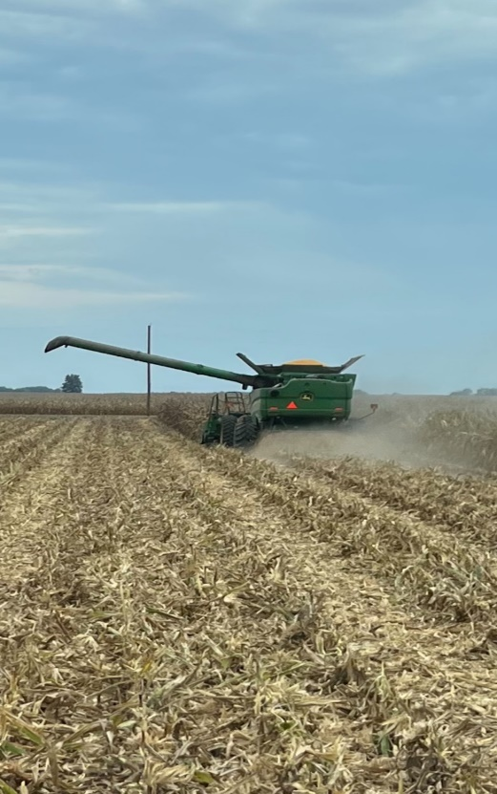
Ballard County Ag News

September
2023

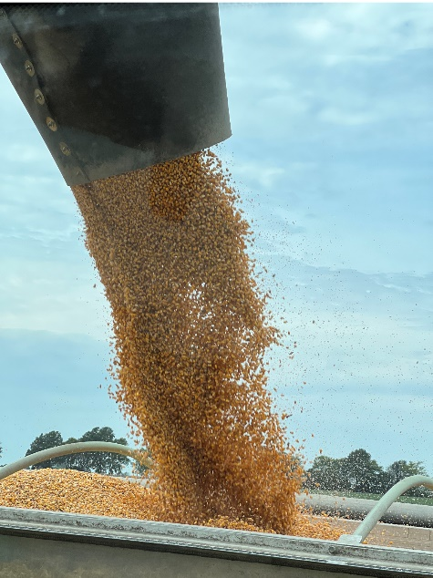

Photos courtesy of Jennifer O’Neill

Corn harvest has started across the county and overall I would say the yields have been slightly better than expected. However, yields are all across the board from under 150 bushels per acre to over 200 bushels per acre. I have not heard any soybean yields yet.

Variations in corn yield comes down to what stage the plant was in, with regard to pollination, when we went through several hot and dry weather events. Grain fill from mid-July on was pretty good with plenty of water and cooler temperatures but the damage was already done. The season started with one of the best overall stands we’ve ever had. If the plant was able to get a kernel started and then keep that kernel, it developed very well. There seems to be much bigger individual grains than usual. A tremendous amount of tip die back has also been seen. Basically, the entire ear got pollinated but it was just too hot and dry to keep them all. Somehow the plant makes a decision on how many kernels it can fill and aborts the rest.

I was on a zoom meeting with the KY Mesonet weather people and one of the presenters was showing how rainfall totals for the year were now above average. I hope I was able to impress upon him how the corn crop doesn’t care what the total was, it only cares what the distribution was. You can’t go from mid- May to mid-July with only a half inch of rain and expect no impact on the corn crop.

Soybeans are significantly better at withstanding periods of drought. I expect a very good soybean crop. Even the double crop beans that had a hard start and a poor stand look like they have been able to overcome a rough start and mature in a hardy fashion.

My biggest wish is for an increase in price. All the commentators talk about lowering the yield forecast in the coming months but if the other areas are similar to us, yields may not be that much lower. Watch for small rallies as a way to lock in a little higher price. I know it is hard to forward contract much production when you have no idea whether you will even have the crop this fall.

What do Higher Profit Farms in Kentucky Have in Common

Kentucky Farm Analysis has put out an article on the differences in the most profitable farms in the state compared to the least profitable. You can read the entire article here: https://agecon.ca.uky.edu/what-do-higher-profit- farms-kentucky-have-common

To summarize the article, data from the Kentucky Farm Business Management program for 2018 through 2022 were used to analyze differences between the highest profit grain farms (high one-third) and the lower profit grain farms (low one-third). The analysis was done for 2022 and for the 2018 through 2022 five-year average on a per acre basis. Farms in the higher profit group were larger, had higher corn and soybean yields, cash rented a larger percentage of their acres, had a larger percentage of their acres in corn, and had higher gross returns and lower costs. Management returns, a profit measurement, were significantly greater for the higher profit farms. Management returns are calculated using gross returns, cash costs, economic (rather than tax) depreciation, and imputed costs for interest and owner

2023 Fall Crop Protection Webinar Series

With the changes in CEU requirements for custom applicators, many of you may be looking for ways to get your continuing education hours. Here is a way to get a few hours over zoom and not have to travel. UK specialists will be conducting webinars in November on various topics. The Thursday morning webinars will take place via Zoom at 10 a.m. EST/ 9 a.m. CST, and pre-registration is required for each webinar. The webinars are open to agriculture and natural resource County extension agents, crop consultants, farmers, industry professionals, and others, whether they reside or work in Kentucky or outside the state.

Dr. Kiersten Wise Webinar #1: Do multiple corn fungicide applications pay? November 2, 2023

Dr. Carl Bradley Webinar #2: What have we learned from nearly two decades of research
on soybean with foliar fungicides? November 9, 2023

Dr Travis Legleiter Webinar #3: Managing the Offensive Spread of Weeds November 16, 2023

Dr. Raul Villanueva Webinar #4: Insects in field crops during 2 years of partial drought and heat wave.

Go to https://www.kygrains.info/ and click on events to see the registration information. Kygrains.info is a clearing house for all our latest grain information.

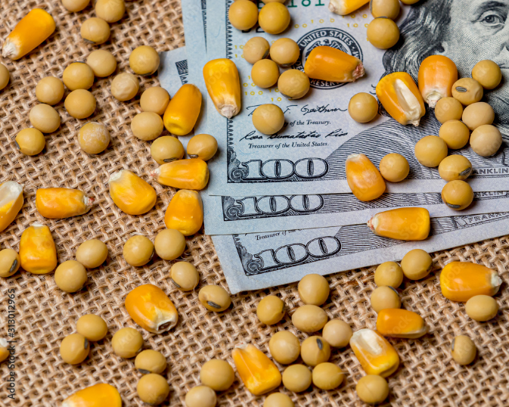
Registration: https://zoom.us/webinar/register/WN_CfQFt0dQSnq5ifdnaSre7A

Farm Bill Update August 29, 2023

Will Snell Extension Professor Ag Economics
This past month Congress has been on its annual August recess and will be returning after the Labor Day holiday to begin the charge to pass a new farm bill. The current 2018 farm bill expires on September 30, 2023. In the midst of anticipated lower future prices for most ag commodities, higher borrowing costs, and reduced ad hoc government outlays for farmers, the ag community is urging Congress to pass this ongoing piece of legislation that has been in place since the New Deal programs of the 1930s. However, upon its arrival back to our nation’s capital, Congress faces a host of appropriation bills that must be passed to keep the government running after September 30th which will likely take on a lot of valuable floor debate and ultimately slow down the progress of a new farm bill. In total, there are only 11 scheduled legislative days when both chambers will be in session during the entire month of September. Although both the Senate and House ag committees have conducted numerous hearings on developing a new farm bill, neither body has “marked up” a bill and passed a bill in committee to deliver to the floor for consideration. So, the bottom line is don’t anticipate passage of the 2023 farm bill prior to the September 30th deadline. Even without a new farm bill by September 30th, many farm bill programs such as farm commodity and dairy support, crop insurance, and nutrition programs will continue with a more pressing deadline of passing a new farm bill before December 31, 2023. While leadership within the ag committees remains optimistic that Congress can send a new farm bill to the President for his signature prior to the end of the year, many challenges loom moving forward.
In reality, not many new issues have evolved since I provided my last update in this newsletter back in late April. Most of the debate has continued to center around crop insurance, reference (safety-net) prices, conservation programs, trade promotion, and of course food assistance programs (i.e., food stamps/SNAP). Traditionally passage of a farm bill has benefited from bipartisan support which will once again be critical to getting this one across the finish line. However, there are plenty of differences on issues across and even within political parties on general farm support and nutrition program structure, eligibility, and funding. Plus, there is the usual debate on equity of program support across commodities and geographical regions.
Funding remains a key challenge moving forward as various agricultural groups are requesting increases in reference prices to offset higher input costs along with additional risk management coverage for specialty crops and livestock enterprises. Environmentalists are seeking additional dollars for expanded conservation programs and technical support. Nutrition supporters are demanding to maintain/increase food assistance for low-income households challenged by this economy. Increases in funding various farm bill programs will likely have to be offset with decreases in funding for other programs as established by the farm bill baseline. If the ag committees can come to an agreement on the components and the funding levels to pass a bill out of committee, then one can likely expect a host of amendments to evolve once the bill hits the Senate and House floors where a block of members on both sides of the aisle have some concerning differences on the “appropriate” level of taxpayer dollars to fund an estimated $1.5 trillion farm bill amidst on-going federal debt/deficit challenges.
Over the past two months, there has also been a lot of attention within the farm bill debate to the concept of “base” acres which are used in the calculations of payments for the two primary safety net programs (Price Loss Coverage (PLC) and Agricultural Risk Coverage (ARC)) for eligible crops (primarily corn, wheat, and soybeans for Kentucky). Base acres within the current farm bill were established over two decades ago and were tied to historical plantings and not to current planted acres. This policy action is designed to allow U.S. producers to make their cropping decisions based on current market conditions and not in response to anticipated government payments. This so-called “decoupling” of the cropping decisions also passes the scrutiny of the World Trade Organization (WTO), the international body that plays referee on policies impacting trade. As a result of policy structure, farmers with eligible base acres can actually receive payments on crops for which they no longer plant.
Given the changes in cropping patterns over the years there are a significant number of planted acres that are not eligible for farm bill safety net payments. This is especially true for soybeans in our state where Kentucky has a tad over 900,000 base acres of soybeans, but in recent years planted around 1.9 million acres of soybeans. Some of these acres might have shifted from one program crop such as wheat to soybeans (and thus retain price/income protection), but there are likely a significant number of farms in Kentucky that have shifted out of livestock or some other non-farm bill enterprise such as tobacco into grain production after the establishment of historical base acres eligible for farm bill payments. The 2014 farm bill did allow farmers a one-time adjustment to reallocate base acres within program crops, but not to increase their total level of base acres.
A recent Senate Ag Committee analysis indicates that Kentucky would be one of 16 states that would benefit from a mandatory update in base acres. However, according to the analysis, the majority of U.S. states would likely observe farm bill payment losses as eligible base acres shift to crops with a lower degree of support within the farm bill. In total, the study indicates a net loss approaching $2 billion with a new mandatory realignment of base acres. While this action could free up some dollars for other farm bill programs/safety net measures, as with any significant policy change there will be winners and losers which may threaten overall support for dramatic changes in the current farm bill structure given anticipated tight vote margins expected to pass a new farm bill.
So hang on for some heated debate and creative budget/policy maneuvers to construct a potential passable farm bill within the next few months … or simply an extension of the 2018 farm bill.
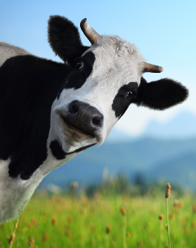

Timely Tips

Dr. Les Anderson, Beef Extension Professor, University of Kentucky

Spring-Calving Cows
- Bulls should have been removed from the cow herd by now! They should be pastured away from the cow herd with a good fence and allowed to regain lost weight and condition. It is a good time to evaluate physical condition, especially feet and legs. Bulls can be given medical attention and still have plenty of time to recover, e.g., corns, abscesses, split hooves, etc. Don’t keep trying to get open spring cows bred – move them to fall calving or sell them when they wean this year’s calf. If you don’t have a bull pen and want to tighten up the calving season, remove the bull and sell him. Plan on purchasing a new bull next spring.
- Repair and improve corrals for fall working and weaning. Consider having an area to wean calves and retain ownership for postweaning feeding rather than selling “green”, lightweight calves. Plan to participate in CPH-45 feeder calf sales in your area.
- Limited creep feeding can prepare calves for the weaning process since they can become accustomed to eating dry feed. This will especially benefit those calves which you are going to keep for a short postweaning period – like the CPH-45 program. It’s time to start planning the marketing of this year’s calf crop.
- Begin evaluating heifer calves for herd replacements – or culling. Each time you put them through the chute you can evaluate them for several traits, especially disposition. Consider keeping the older, heavier heifers. They will reach puberty before the onset of the breeding season and have higher conception rates.
- This has generally been a good year for pastures, but many parts of the state are starting to get a bit dry. Evaluate moisture condition and consider stockpiling some fescue pastures. It’s not too late to apply nitrogen for stockpiling fescue if moisture conditions have improved.
- Stresses associated with weaning can be minimized by spreading-out other activities commonly associated with weaning – like vaccinations, deworming, castration and dehorning (which should have already been done!). Therefore, this month is a good time to do a “preweaning” working of cows and calves.
- When planning the preweaning working, consult with your veterinarian for advice on animal health products and procedures. One procedure that can be done now is pregnancy checking cows. Early pregnancy diagnosis will allow time to make culling decisions prior to weaning time. Feeding non-productive cows through the winter is a costly venture so pregnancy diagnosis is a sound business decision a producer can make.
Fall-Calving Cows
- Fall-calving should start this month. Get your eartags ready. Cows should be moved to a clean, accessible pasture and be watched closely. Tag calves soon after they are born and record dam ID and calf birthdate, etc. Castration is less stressful when performed on young animals and calves which are intended for feeders can be implanted now, too.
- If you haven’t started calving quite yet, then it’s time to get ready. Be sure you have the following:
- record book
- eartags for identification
- odine solution for newborn calf’s navel
- calf pullero castration equipment
- Watch for those calves which may come early and be prepared to care for them.
- Be on the guard for predators – especially black vultures.
- Move cows to high quality fall pasture after calving. Stockpiled fescue should be available to these cows in November-December to meet their nutritional needs for milking and rebreeding.
- Start planning now for the breeding season. If using AI, order supplies, plan matings and order semen now.
Stockers
- Calves to be backgrounded through the winter can be purchased soon. A good source is Kentucky preconditioned (CPH-45) calves which are immunized and have been preweaned and “boostered”.
- Plan your receiving program. Weanling calves undergo a great deal of stress associated with weaning, hauling, marketing, and wide fluctuations in environmental temperature at this time of year. Plan a program which avoids stale cattle, get calves consuming water and high-quality feed rapidly. Guard against respiratory diseases and other health problems.
General
- Always keep a good mineral mix available. The UK Beef IRM Basic Cow-Calf mineral is a good option.

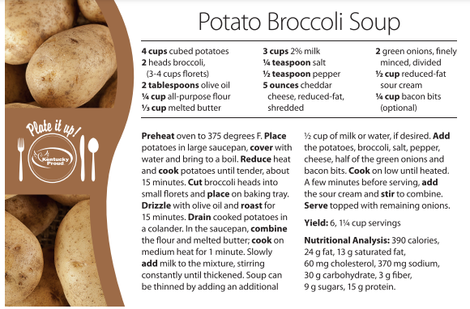

Released by:

Extension Agent for Ag and Natural Resources
